Evaluating Predictive Techniques to Model Stochastic Airport Passenger Flow

by

Leila Gleich

A Graduate Capstone Project Submitted to the College of Aviation,
Department of Aeronautics, in Partial Fulfillment
of the Requirements for the Degree of
Master of Science in Aeronautics

Embry-Riddle Aeronautical University
Worldwide Campus
May 2026
THE APPLICATION OF PREDICTIVE ANALYTIC TECHNIQUES TO OPTIMIZING AIRPORT PASSENGER FLOW

by

Leila Gleich

This Graduate Capstone Project was prepared under the direction of the candidate’s Graduate Capstone Project Chair, Mark Miller,
Worldwide Campus and has been approved. It was submitted to the
Department of Graduate Studies in partial fulfillment
of the requirements for the degree of
Master of Science in Aeronautics

Graduate Capstone Project:

___________________________________________
XXXXXXXX.
Graduate Capstone Project Chair

________________
Date

Acknowledgements
I'd like to thank the opportunities I’ve had to understand the extent airport operations can be improved and support both local and global communities.

Abstract
Scholar: Leila Gleich
Title: Evaluating Predictive Techniques to Model Airport Passenger Flow
Institution: Embry-Riddle Aeronautical University
Degree: Master of Science in Aeronautics
Year: 2026
This study explores how to improve passenger flow operations in airports by analyzing different tools that employ predictive analytics.
Table of Contents
Table of Contents
Acknowledgements iii
Abstract iv
Chapter I 1

List of Tables
List of Figures

Chapter I
As air travel demand outpaces airport infrastructure growth, inefficient resource allocation has become a critical operational bottleneck (Adacher, Flamini, Guaita & Romano, 2017). While existing predictive models are increasingly used to forecast airport passenger flow management, the systemic shocks of the COVID-19 pandemic underscored limitations within traditional, accuracy-centric performance metrics to handle abrupt demand shocks, structural breaks, and changing operating constraints. These unprecedented operational disruptions demonstrated that conventional accuracy metrics, while necessary, are insufficient as the sole basis for evaluating models intended for volatile airport operating environments. Specifically, the pandemic revealed that a singular evaluation standard is inadequate across highly variable operational contexts, necessitating the assessment of predictive models through a broader, multidimensional set of performance measures. In airport operations, the most useful predictive model is therefore not necessarily the one with the lowest average forecast error, but the one that remains reliable during disruption (robustness), recovers effectively as conditions evolve (resilience), and transfers across operational contexts (generalizability). This study examines the suitability of predictive models - specifically for forecasting TSA throughput - across routine, traditional, and disrupted demand conditions when model performance accuracy is assessed in the context of resilience, robustness, and generalizability.
Significance of the Study
This research aims to contribute to both theory and practice by shifting the paradigm of how predictive models are evaluated in unpredictable airport operations. While traditional approaches emphasize static accuracy, this study advances the field by establishing a multidimensional, dynamic evaluation framework that assesses models based on their robustness, resilience, and generalizability. By identifying which forecasting techniques remain reliable during operational disruptions and structural breaks, it offers airport operators actionable, data-driven insights for selecting models that sustain TSA throughput, safety, and service rates under fluctuating post-pandemic conditions.
Statement of the Problem
Airport passenger arrivals and behaviors are inherently stochastic, varying significantly by time of day, flight schedules, and external factors (Cheng, Zhang, & Guo, 2012; Dönmez, Tükenmez, & Cecen, 2025). Existing models for managing airport passenger flow tend to rely on static or pre-pandemic assumptions, consequentially failing to account for unpredictable post-pandemic travel patterns (Ebert, Dutta, Mengersen, Mira, Ruggeri, & Wu, 2021; Hopfe, Lee & Yu, 2024). This mismatch between capacity planning and fluctuating passenger demand contributes to bottlenecks at check-in counters, TSA checkpoints, and boarding gates, ultimately leading to congestion and inefficient resource allocation. While recent global disruptions have proven that historical baselines are insufficient for contemporary airport logistics, the aviation sector currently lacks a dynamic framework for evaluating predictive models beyond standard accuracy metrics. Because modern forecasting can no longer remain predicated on deterministic conditions, the absence of an adaptable evaluation methodology leaves airports at risk of deploying tools that fail to respond to sudden demand shocks or generalize across shifting operational realities.
Purpose Statement
The primary objective is to evaluate predictive modeling techniques, such as regression, machine learning, and queuing simulation, to optimize airport capacity via technological rather than physical – and more costly – intervention. By analyzing the relationship between flight operations and TSA throughput, this study evaluates various predictive modeling frameworks against the primary criteria of robustness, resilience, and generalizability. Rather than seeking a singular, universally optimal model, this research identifies which frameworks perform best under each distinct metric. Ultimately, this comparative analysis provides management with the strategic flexibility to adopt the most appropriate forecasting approach based on their specific operational priorities.
Research Question
Which predictive modeling frameworks are most effective for forecasting airport passenger flow when prioritizing robustness, resilience, or generalizability as the primary evaluation metric?
Delimitations
This study focuses on U.S. airports and uses post-pandemic TSA throughput and flight performance data from 2019 to 2025. It excludes pre-pandemic and pandemic-period activity except where needed to define the post-pandemic baseline. Dynamic queuing models and simulation-based methods are assessed using standard statistical measures, including p-value, R² squared, mean squared error (MSE), root mean squared error (RMSE), and mean absolute percentage error (MAPE).
Limitations and Assumptions
Due to reliance on public data, confidential variables like staffing and manual queue management fall outside the scope of this analysis. While external factors such as weather, regulatory impacts, or IT outages may not be fully accounted for, the framework assumes that utilized data is consistent and findings from the selected airports are generalizable across similar facilities and circumstances. Additionally, the methodology relies on the ability to apply monthly data on load factor to the prediction of TSA throughput on an hourly and seasonal level.

Chapter II
Review of Relevant Literature
As the air transportation network navigates a period of expansion that threatens to outpace the physical limitations of existing infrastructure, the impractical expectation of immediate structural capacity expansion has pivoted operational priorities toward refining asset distribution. Traditional optimization methods often rely on static, deterministic approaches – which operate on the premise of predictable, non-random outcomes – but intrinsically fail to account for the stochastic nature of real-time terminal activity. To address these gaps, researchers are developing models designed to optimize resource allocation, such as staffing and throughput management, while maintaining efficient, high-quality service. Integrating advanced predictive frameworks offers the potential to build the robust, resilient, and generalizable tools necessary to manage variability and balance competing operational demands under uncertainty. Historically, literature on airport passenger flow modeling has prioritized statistical fit and throughput optimization. The unprecedented systemic shocks of the COVID-19 pandemic exposed the limitations of relying solely on historical data for predictive accuracy. Consequently, this review traces the evolution of flow prediction from static operational models to advanced deep learning architectures, ultimately highlighting a recent paradigm shift toward frameworks that prioritize systemic resilience and robustness in the face of extreme disruptions.
The literature review is structured as follows: first, traditional approaches to airport capacity and passenger flow are reviewed; second, the shift from static to dynamic modeling is explored; third, advanced predictive models and artificial intelligence are analyzed regarding their strengths and limitations; and finally, hybrid architectures are discussed as a synthesis to achieve both predictive power and transparency. This trajectory illustrates a critical shift from rigid observations toward dynamic predictive models that link theory with real-time operations.
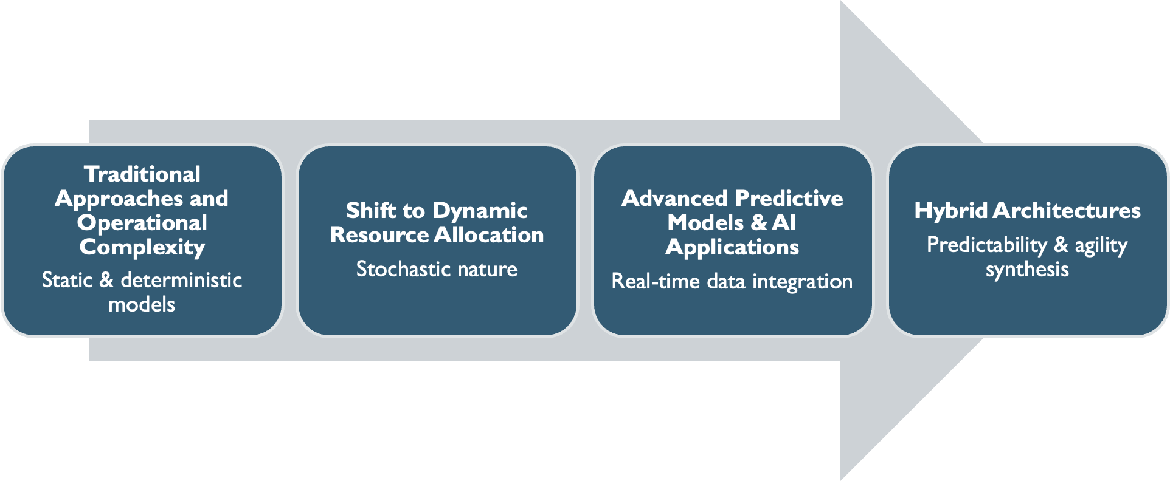
Figure 1. Literature Review Outline
1. Traditional Approaches and Operational Complexity
Mounting demand for air transport has resulted in an operational environment in which traditional infrastructure can no longer keep pace with escalating passenger volumes, as noted in industry analyses (Ozores, 2026). While domestic passenger demand in the US is projected to grow by 2.4% annually, airport capacity is forecasted to increase by only 0.8%, yielding a critical and widening gap that is unlikely to be resolved by physical expansion alone (IATA, 2026; FAA, 2024). This discrepancy is further complicated by the high levels of uncertainty inherent in long-term demand forecasting, a factor that consistently renders large-scale capital investments in terminal capacity both risky and slow to respond to immediate surges (Solak et al., 2009). As structural expansions lack the agility required for near-term solutions, the industry must pivot toward maximizing existing assets through advanced resource optimization (Balliauw & Onghena, 2020; Zhang et al., 2012). Araujo & Repolho (2015) argue that due to the stochasticity and interdependence of terminal subsystems – namely check-in, security, and boarding queues - managing their complexity requires the identification and reduction of the superfluous operations that lead to bottlenecking. To achieve sustainable capacity, terminal functional areas must maintain a specific Level of Service (LOS) without the prohibitive capital expenditure of hard infrastructure expansion (Di Mascio et al., 2020; AlKheder et al., 2024).
The delicate interdependency of airport subsystems further complicates operational shifts, as localized failures in one segment are particularly vulnerable to time-related constraints, potentially triggering a systemic collapse of flow (Orhan & Orhan, 2020; Bießlich et al., 2014; Brown & Madhavan, 2011). Systemic fragility is exacerbated by the interlocking nature of landside and airside events, where a delay in one sector propagates a cascade of congestion across the entire airport ecosystem (Nazir et al., 2022). Furthermore, congestion does not occur linearly; traffic frequently occurs in high concentrations – "starving" capacity for hours before suddenly "saturating" it in minutes – transforming flow optimization into a moving target that outpaces nominal capacity growth (Chiti, Fantacci & Rizzo, 2018). Even when a facility remains under its total daily limits, unexpected arrival fluctuations create "ripples" of upstream congestion, inevitably disrupting downstream processes like security screening (Adacher & Flamini, 2020; Marzuoli et al., 2019). This operational friction is intensified by a persistent temporal lag: a systemic mismatch in which the time required to detect a surge forces additional resources to become available only after the peak has subsided. Ultimately, these bottlenecks are rooted in the unpredictable, stochastic nature of passenger behavior, making resource allocation a complex balancing act between operational costs and quality service levels (Birolini & Jacquillat, 2023).
1.1 Stochasticity and Batch Behavior
Understanding modern airport capacity and the corresponding resource allocation crisis requires looking beyond the simple reality of demand exceeding supply (Fernandes & Pacheco, 2002). Historically, airport landside management relied on deterministic models which assumed that fixed passenger volumes would result in linear, predictable service requirements (Lemer, 1988; Parizi & Braaksma, 1994). In contrast, contemporary operations are more appropriately understood as a network of interconnected queues, characterized by intricate, non-linear movements. While transitioning toward probabilistic models allows for a more nuanced approximation of system behavior, the unpredictable variables of the terminal environment continue to make fluctuating dynamics notoriously difficult to capture.
The stochastic nature of passenger flow and “batch” behavior further compounds modeling difficulties, highlighting that spatial capacity increases alone cannot resolve modern convolutions. In airport operations, stochasticity – random variables such as varying arrival times and individual walking speeds – renders human movement inherently unpredictable despite fixed flight schedules (Schultz & Fricke, 2011). This randomness frequently manifests as “batch” behavior, where passengers do not arrive in a steady stream, rather in concentrated bursts that overwhelm localized infrastructure (Guo et al., 2022). Even with perfect flight data, arrival patterns remain a non-deterministic system due to interacting operational and behavioral factors. Models must be designed not just for volume, but also to schedule resources around these bursts without incurring the cost of constant over-staffing.
1.2 Queuing Theory Foundations and Limitations
To translate unpredictable passenger movements into quantifiable system states, traditional landside optimization methods utilize Queuing Theory. Queuing Theory models how stochastic arrival patterns and concentrated "batches" of passengers interact with various service points throughout the terminal (Wang, 2017). In this framework, every terminal process – from check-in to security screening – is treated as a "server" processing "entities." Early iterations of these models utilized a Poisson process distribution to calculate the probability of specific arrival rates within fixed intervals to account for the inherent uncertainty of passenger demand (Horie, 1985; Odoni, 1986). This established a vital mathematical foundation by demonstrating that wait times do not increase linearly, allowing for a calculated trade-off between operational costs and a target Level of Service (LOS) (Araujo & Repolho, 2015).
Because the standard Poisson distribution assumes a constant arrival rate, it consistently struggles to reflect non-linear dynamics and dramatic fluctuations triggered by flight banks (Wang, 2018). Within an operational context, flight banks - the temporal compression of multiple flight schedules into narrow windows - act as the primary driver of "batch behavior" in terminal queues (Peterson et al., 1995). Concentration of demand forces the system to process massive, non-linear surges that can saturate capacity far more rapidly than a steady, continuous stream. To address this, researchers transitioned toward Non-Homogeneous Poisson Processes (NHPP), effectively treating the terminal as a multiphase network where the output of one process becomes the variable, time-dependent input for the next (Brunetta et al., 1999). One approach to expanding terminal flow efficiency involves modeling the airport as a multiphase single-server queuing system, which allows for the prediction of congestion and unused capacity by calculating performance indicators like traffic intensity and average wait times across sequential service points (Hess & Grbčić, 2019).
Data-driven queueing approaches have been used to bridge the gap between theoretical flight schedules and actual passenger surges (Nikoue et al., 2015). Alnowibet et al. (2022) demonstrate the utility of queuing theory to identify specific bottlenecks at Cairo International Airport, noting that server utilization often exceeds capacity in the check-in and security sub-systems during peak hours. Virtual queuing theory and bottleneck detection algorithms have frequently identified security checkpoints as the primary decelerators of terminal throughput (Liu, 2018; Lu et al., 2018). Beyond identification and basic flow, optimization models utilizing Generalized Stochastic Petri Nets (GSPN) have been employed to specifically reduce the “dead time” between security screening stages, thereby increasing the overall service rate of the checkpoint (Wei, 2017; Zhang et al., 2017).
Even as network-centric approaches were refined through likelihood-free inference for dynamic queuing networks to better estimate time-varying surges, they remained conceptually limited (Ebert et al., 2021). By relying on the independence assumption of the Poisson process, the ability of traditional models to account for critical elements is fundamentally limited in two ways: the correlation between passengers on the same flight and the “batch” behavior inherent in modern hub-and-spoke operations (Guo et al., 2022). As Adeke (2018) demonstrates, while queuing theory provides a foundational framework for modeling passenger flow, its simplifying assumptions limit its ability to capture the full complexity of real-world terminal dynamics.
2. From Analytical Queuing Models to Dynamic Simulation and Real-Time Management
To navigate the inherent uncertainty of terminal operations, researchers have advocated for a stochastic planning approach that redefines terminal management as a probabilistic system (Verki et al., 2013). Central to this shift is Discrete Event Simulation (DES), a modeling method which – unlike a static spreadsheet – views terminal processes as a sequence of discrete events where every action, such as a passenger finishing check-in or entering a security lane, is recorded within a time-indexed framework (Brown & Madhavan, 2011). To resolve analytical gaps, researchers utilize DES to capture spatial, temporal, and behavioral variability that static models cannot represent (Leone & Liu, 2011). By acting as the underlying engine, DES provides the simulation capabilities necessary for a broader Digital Twin framework: a continuously updated virtual replica that mirrors physical infrastructure in real-time (Edwards, 2026). By utilizing DES to calculate the stochastic nature of processes like fluctuating TSA throughput, a Digital Twin becomes a dynamic, data-fed model that learns how assets behave under real operating loads to predict future performance and potential failures. The corresponding high-fidelity granularity is essential for resource allocation because it allows for the integration of human unpredictability (Perez, 2021).
In practice, these allocation models have proven highly effective. Guizzi et al. (2009) demonstrate a strong correlation between check-in throughput and security demand, providing a framework for more rational resource management. The resulting paradigm shift is further supported by event-based allocation methods that utilize empirical data to dynamically schedule check-in counters in response to fluctuating demand (Parlar et al., 2016). Nwofia and Chung (2013) underscore the utility of probabilistic simulations by demonstrating the ability to build a link between architectural design and financial accountability. Ultimately, the "digital twin" approach enables the testing of hypothetical flight schedules that can reduce peak terminal density and assess if optimization models meet real-world service levels under uncertainty (Araujo & Repolho, 2015; Ateş et al., 2021).
2.1 The Limitations of DES
Despite its high fidelity, Discrete Event Simulation (DES) remains constrained by predefined logic structures, making it highly sensitive to parameter assumptions and less adaptable to real-time deviations (Takakuwa & Oyama, 2004). Brown and Madhavan (2011) illustrate this vulnerability, showing how checkpoint throughput can be disproportionately skewed by baggage alarm rates; such minor fluctuations in human or machine performance can significantly distort outputs when the underlying logic is unable to pivot. Furthermore, Alodhaibi et al. (2017) argue that using a fixed logical sequence treats passengers as passive entities rather than proactive decision makers. The resulting behavioral and structural rigidity creates a modeling gap during terminal disruptions, where the methodology struggles with the computational intensity required to simulate highly stochastic, unfolding events (Bießlich et al., 2014). Consequently, the limitations of rule-based fidelity under rapidly changing conditions motivate a transition in the research landscape toward data-driven systems that can actively learn from operational data, rather than merely following static scripts.
2.2 Recontextualizing Poisson
Poisson arrival processes have traditionally served as a foundational cornerstone of queueing theory; however, recent research – as seen in the MATLAB-based algorithm – recontextualizes these distributions within more advanced predictive frameworks (Palaşcă & Stăncel, 2025). By utilizing Poisson models as the stochastic core for real-time data processing, airports can achieve significant gains in operational efficiency. The purpose of such integration is to identify congestion hotspots and enable dynamic resource adjustment, effectively reducing the excess operating hours and salary costs associated with fixed staffing.
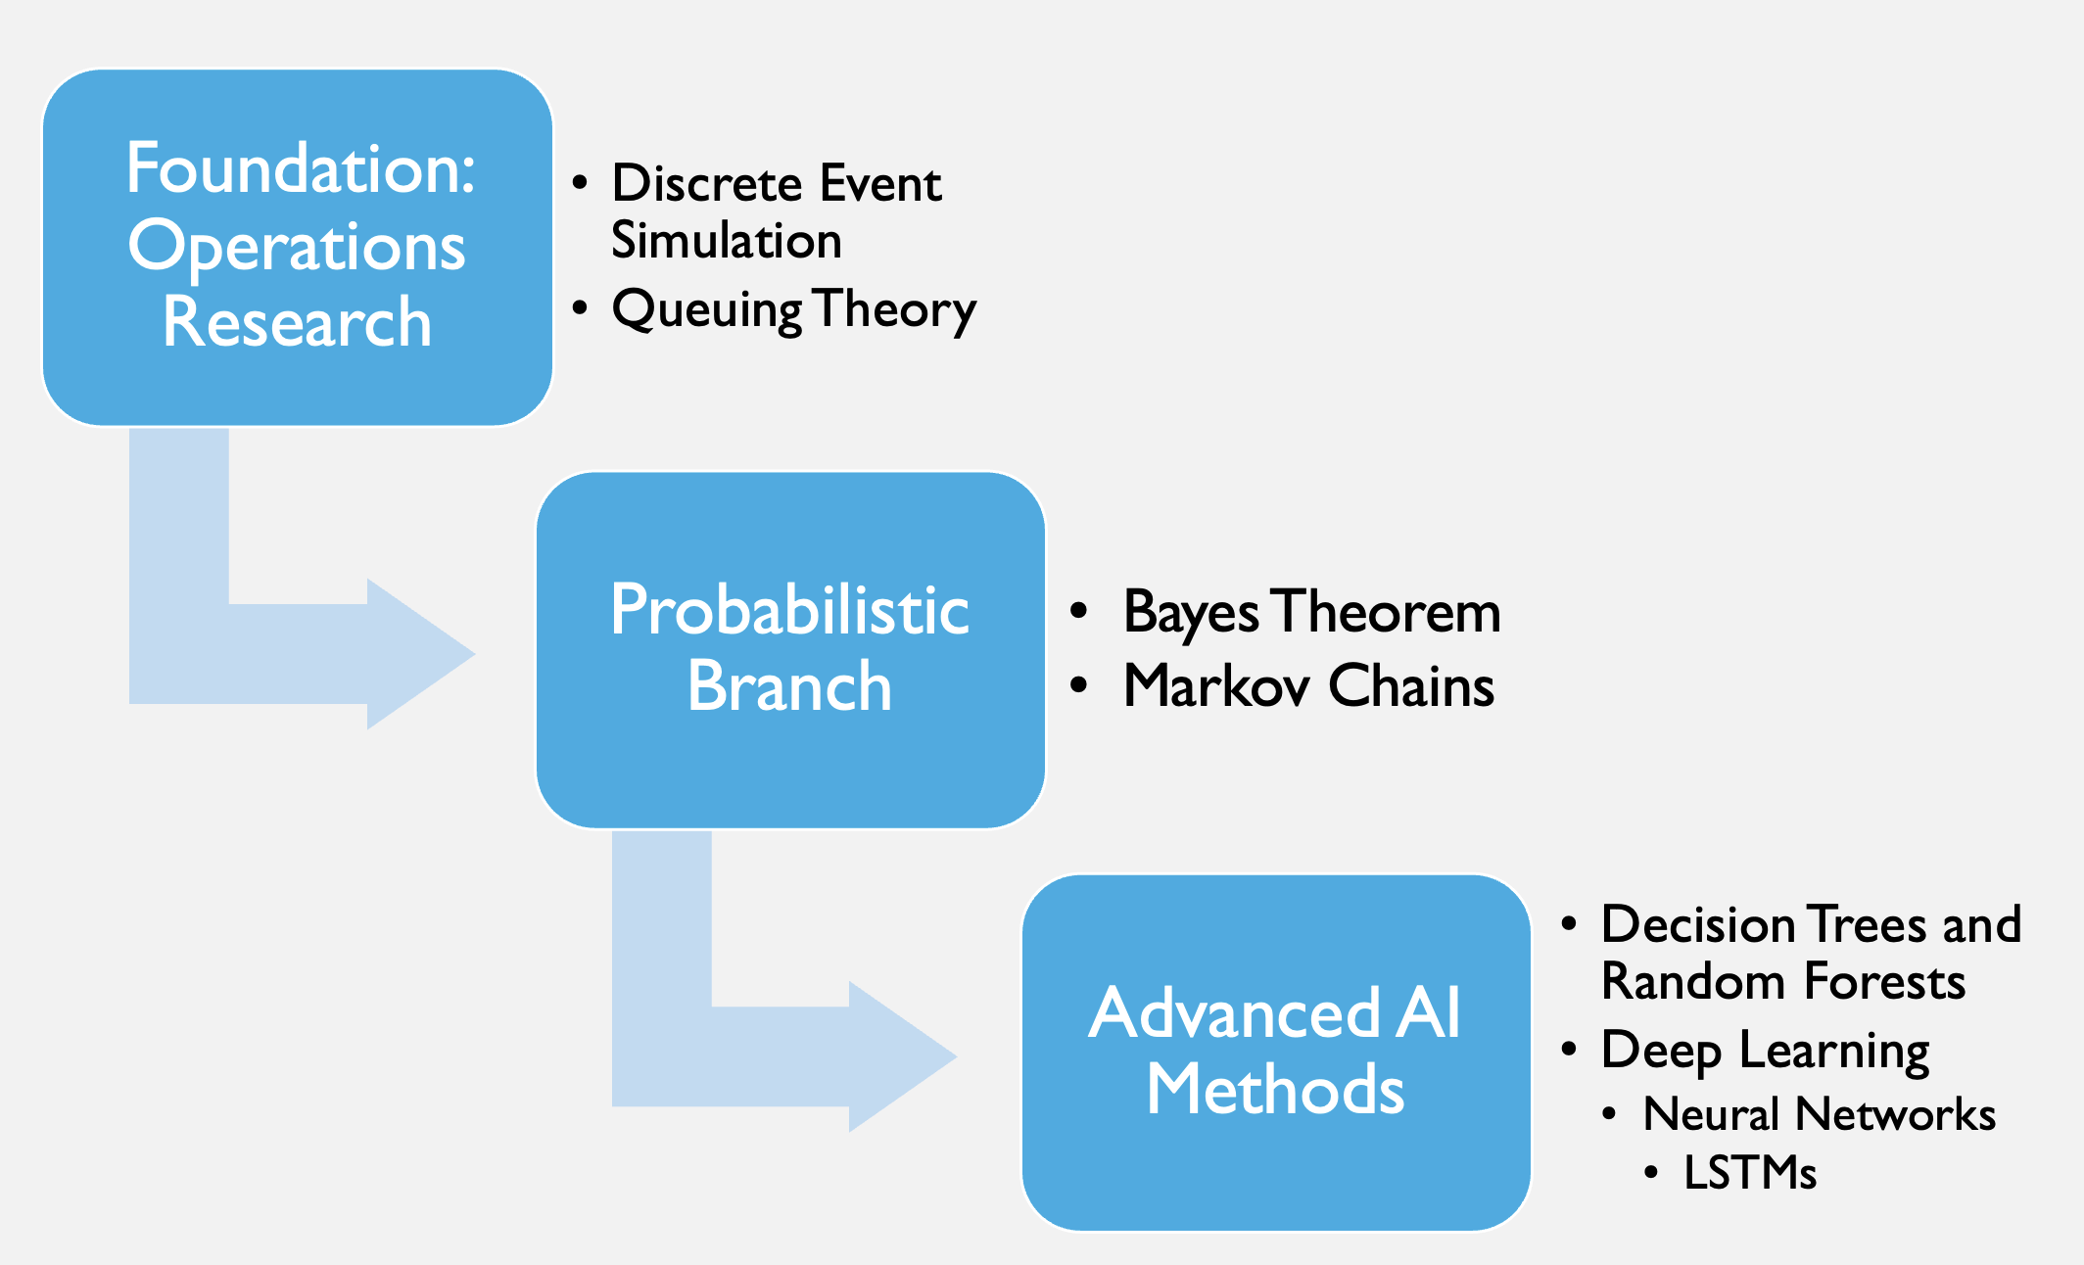
Figure 2. Methodological Hierarchy

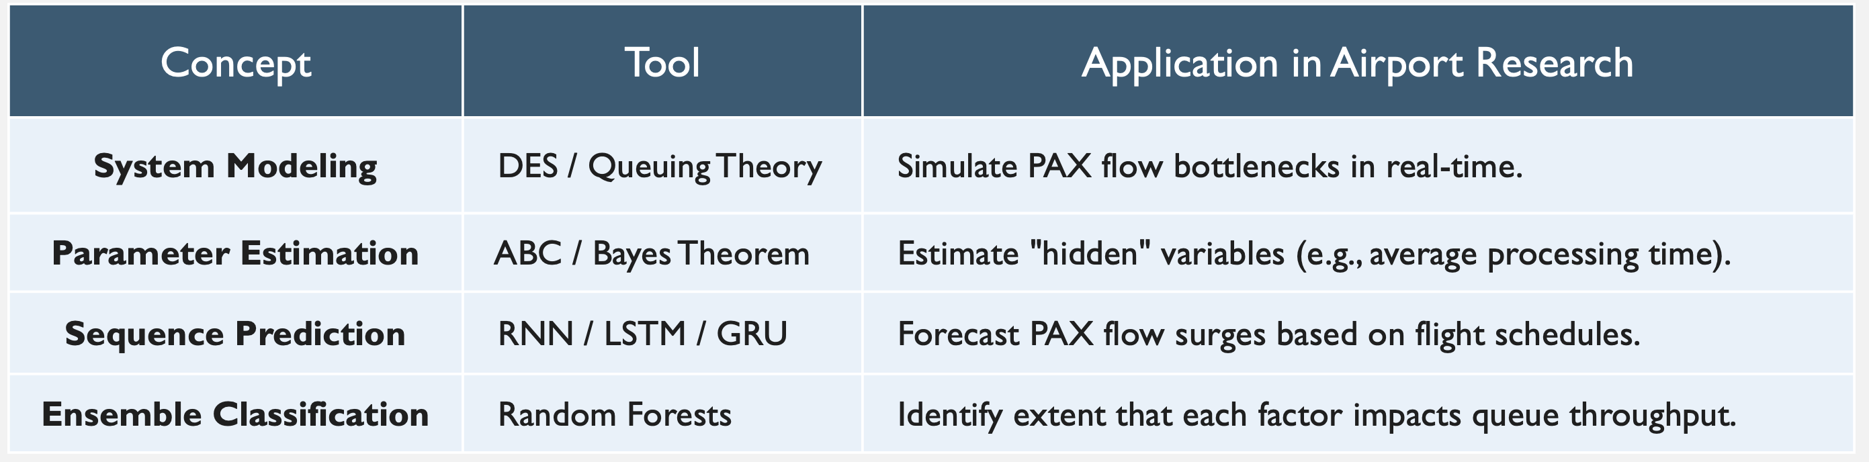
Figure 3. Concept Comparison
3. Advanced Predictive Models and Artificial Intelligence
The limitations of traditional simulation have necessitated a shift toward advanced predictive architectures that prioritize operational flexibility and real-time responsiveness over static process logic. Unlike the rigid nature of early discrete event simulations, these modern architectures serve as the foundation for robust resource allocation by absorbing vast streams of real-time data to forecast emergent behaviors. This evolution represents a fundamental move toward probabilistic reasoning, where the objective is to model the likelihood of various outcomes rather than relying on a single deterministic path.
3.1 Time-Series Analysis and Statistical Foundations
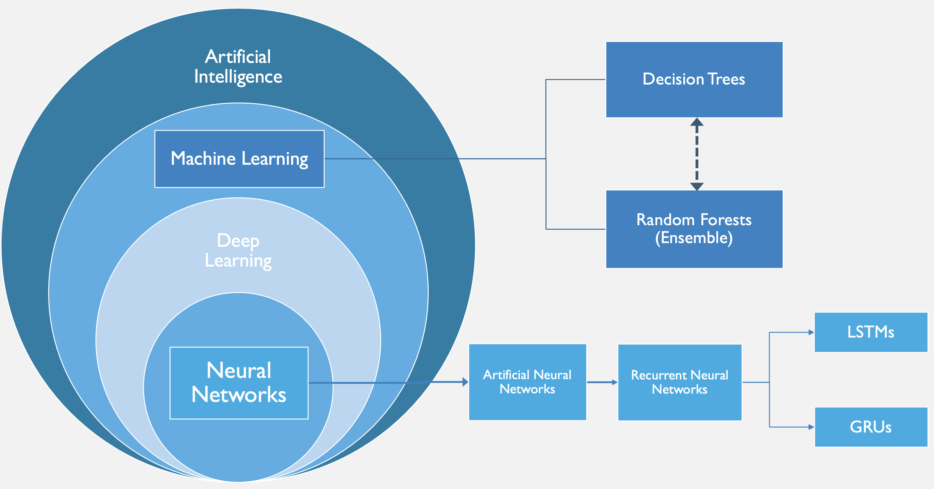
Figure 4. Artificial Intelligence Hierarchy
The adoption of Artificial Intelligence (AI) represents the technical realization of this shift through Machine Learning (ML), a subset of AI that moves beyond pre-programmed rules to serve as a pattern-recognition tool capable of managing the stochastic "noise" of passenger behavior (Saki & Soori, 2026). Traditionally, SARIMA (Seasonal Autoregressive Integrated Moving Average) models have been used to identify recurring patterns by analyzing the internal properties of a univariate time series, such as the autocorrelation of past arrival waves and daily seasonal cycles. By mathematically 'averaging' its own historical errors and trends, SARIMA effectively captures the predictable rhythms of flight banks and holiday travel (Babu, 2014). However, while SARIMA excels at internal pattern recognition, high-fidelity forecasting must also account for the direct correlation between fluctuating passenger volumes and specific, real-time flight arrangements (Lin et al., 2023). Because SARIMA’s predictive power is derived entirely from its own historical data, it remains fundamentally unable to incorporate these external shocks directly into the univariate time series (Li et al., 2017).
3.2 Neural Networks and High-Dimensional Data
To account for non-linear temporal dependencies that statistical models cannot represent, models such as Long Short-Term Memory (LSTM) networks are particularly effective. Unlike traditional SARIMA models, LSTMs can learn complex, non-linear long-term dependencies between past arrival waves and future terminal surges, effectively reflecting the external influences that statistical models tend to overlook (Hewamalage et al., 2021). While Orsini et al. (2019) highlight the necessity of the recurrent nature of LSTMs for predicting real-time passenger journeys, the computational demands of such models limit their strategic application. Consequently, dense neural networks provide a computationally efficient alternative for capturing the non-linear surges inherent in airport traffic; a compact, dense architecture achieves high-fidelity forecasting with minimal overhead. Simulation data farming underpins the enhancement of robustness in these predictive tools, offering a pathway to generate the vast datasets necessary for training machine learning models within elaborate security subsystems (Patrón et al., 2021).
3.3 Behavioral Modeling and Active Control
Recent work extends beyond passive flow prediction by modeling passengers as adaptive agents capable of dynamic decision-making within terminal environments. To better simulate proactive decision-making, multi-agent reinforcement learning has been utilized to model how autonomous passenger "agents" navigate and adapt to terminal constraints (Li & Gao, 2023). However, the practical application of these systems reveals a functional gap, as models frequently underestimate actual flow even when utilizing high-resolution distributional forecasts (Anagnostopoulou et al., 2024). To bridge the gap between prediction and operational execution, recent research has moved toward structured control frameworks. Diaz-Gutierrez et al. (2025) demonstrate this evolution by introducing Model Predictive Control (MPC) algorithms that integrate stochastic airport dynamics into an automated optimization loop. This marks a critical evolution from pure prediction toward active control, where dynamic rescheduling strategies are used to balance congestion across multiple departure areas in real time (Lee et al., 2025). Together, these approaches demonstrate that although predictive accuracy has improved significantly, challenges remain in the interpretability and operational integration, formerly facilitated by simpler, deterministic methods. This transition necessitates the adoption of the hybrid models explored in the following section.
4. Hybrid Architectures: Integrating Determinism and Interpretability
To resolve the "black-box" challenge – where the internal logic of deep learning models is not easily interpretable – researchers increasingly advocate for hybrid architectures (Adadi & Berrada, 2018). In these architectures, neural networks act as predictive engines that generate flow estimates, which are then passed to a secondary optimization layer – notably Simulated Annealing or Integer Linear Programming (ILP) – to align with real-world operational constraints and staffing buffers (Brun et al., 2025). The subsequent need for integration is reflected in approaches that combine Random Forest predictions with deterministic queue-length models to produce actionable, flight-level insights (Had et al., 2025). By linking probabilistic forecasting with constraint-based optimization, hybrid architectures provide a more adaptable and scalable framework for managing airport operations across varying conditions (Jenčová et al., 2025).
4.1 Fusion and Deep Learning Stability
Early hybrid approaches focused on improving predictive stability by integrating deep learning with statistical methods. Hopfe et al. (2024) show that combining Gated Recurrent Units (GRU) with regression and gradient boosting improves accuracy by incorporating external variables such as weather, search behavior, and mobility patterns. Similarly, Ribeiro et al. (2025) find that embedding queuing-theoretic features into Gradient Boosting Machines (GBM) enhances the model’s ability to capture non-linear congestion dynamics compared to purely data-driven or analytical approaches.
This integration strengthens the representation of physical system constraints while preserving the predictive power of machine learning. More recent work extends the idea through multi-layered architectures designed to capture patterns at different scales. For example, the Fusion Intelligence Network Model (FINM) proposed by He et al. (2024) combines Convolutional Neural Networks (CNN) for local feature extraction, Bidirectional Long Short-Term Memory (BiLSTM) for temporal context, and GRUs for computational efficiency. By distributing tasks across specialized components, these architectures improve stability under rapidly changing traffic conditions, although they still depend on data quality and model calibration.
4.2 Causal Transparency: Transitioning to “Glass-Box” Models
Multi-layered models possess considerable predictive power, yet they commonly remain difficult to interpret (Wang et al., 2025). This lack of transparency is a critical hurdle for operational deployment, where understanding the 'why' behind a prediction is as vital as the prediction itself (Viaña et al., 2024). Bayesian Networks (BNs) offer a potential solution by representing probabilistic dependencies in a transparent, causal structure (the ‘why’). Guo et al. (2025) extend this framework by integrating BNs with the Best-Worst Method to quantify interdependencies among terminal resilience factors. Quantifying these variables allows models to move beyond static throughput metrics and incorporate both technical constraints and human-driven variability. Similarly, Hybrid Queue-based Bayesian Networks (HQBN) combine queuing theory with probabilistic reasoning to identify the causes of congestion within terminal processes. By linking prediction with causal interpretation, these models support more informed and explainable decision-making in resource management (Wu et al., 2014).
4.3 Stochastic Optimization
An additional requirement for effective hybrid systems is the ability to manage uncertainty through stochastic optimization. Metaheuristic methods—such as Particle Swarm Optimization with Back Propagation (PSO-BP)—are widely used to tune neural network parameters, improving performance on non-linear variables like baggage flow and waiting times (Naji et al., 2020; Jiang et al., 2024; Wu, 2024). These approaches provide near-optimal solutions without requiring exhaustive search, making them suitable for complex, high-dimensional systems (Sörensen, 2015).
To maintain performance under noisy or incomplete data, likelihood-free inference methods can be used to estimate system behavior during unpredictable disruptions (Ebert et al., 2021). Nonlinear Autoregressive with Exogenous Input (NARX), a complementary model, incorporates external variables like weather, improving forecast transparency compared to purely deep learning approaches (Anupam & Lawal, 2024). These predictive components are commonly validated within simulation environments (e.g., ARENA), linking learned behavior back to operational testing (Olusanya et al., 2020; Oprea et al., 2024).
Additional interpretability can be introduced through Fuzzy Logic systems, which model decision-making under uncertainty, and ensemble methods such as Random Forests, which improve robustness by aggregating multiple decision pathways (Xia et al., 2020; Blasco-Puyuelo et al., 2023). These methods support applications like dynamic passenger routing, where real-time guidance directs travelers toward underutilized resources (Yang et al., 2022). Despite their power, many non-linear models still trade interpretability for accuracy, highlighting the necessity of hybrid approaches that balance performance with transparency (Wu et al., 2024).
Ultimately, the evolution of airport passenger flow predictive modeling represents a distinct shift toward architectures that prioritize robustness and resilience over mere statistical fit. Evidence from Hopfe et al. (2024) suggests that deep learning models, particularly multivariate LSTMs, better capture non-linear interactions during periods of disruption when used in conjunction with additional deterministic models. Although forecasting technologies have significantly advanced in predicting passenger flow and baseline volatility, COVID-19 pandemic served as an unprecedented system disruption that exposed the profound vulnerabilities of static operational models.
5. Impact of COVID-19
While predictive modeling for airport passenger flow utilizes probabilistic methods capable of processing both pre-pandemic and pandemic data, the unprecedented operational shocks of COVID-19 revealed a critical vulnerability in how these models are evaluated (Sun et al., 2022). Existing frameworks proved ill-equipped to account for extreme, abrupt disruptions in the commercial air traffic industry. The pandemic fundamentally altered terminal operations as airports were driven to restructure passenger handling, shifting priorities away from speed-centric throughput toward the minimization of public health risks (Mota et al., 2021). As even highly sophisticated models struggled to accurately forecast flow amidst these profound spatial and procedural changes, it became evident that raw predictive accuracy could no longer serve as the sole benchmark for a model's efficacy (Li et al., 2023). Consequently, the systemic disruptions of COVID-19 drove a paradigm shift in airport passenger flow operations, prioritizing robustness, resilience, and generalizability as primary evaluation criteria.
Robustness to Procedural Volatility (Performance Under Perturbation)
The rapid adoption of digital and self-service processes initially introduced highly volatile processing times, transforming automation from a reliable accelerator into a potential operational bottleneck (Lin, 2022). Consequently, predictive models must now be evaluated on their robustness—their capacity to adapt to sudden shifts and treat these dynamic, unpredictable processing times as active variables rather than stable baselines.
Resilience to Systemic Shocks (Capacity to Absorb and Recover from Disruption)
Terminals witnessed the emergence of decentralized queue structures, physical barriers, and curtailed staffing levels to align with diminished and unpredictable passenger demand (Schultz et al., 2021; Kazda et al., 2022). This structural upheaval necessitates an emphasis on resilience, ensuring models can withstand severe systemic shocks and accurately map extreme demand fluctuations alongside sudden physical capacity constraints.
Generalizability Across Environments (External Validity)
The pandemic revealed that ostensibly "similar" airports harbored drastically different underlying structural vulnerabilities, demonstrating that comparable variables could not uniformly explain the volatility of passenger flow across different hubs (Güner & Seçkin Codal, 2024). Moreover, confounding factors - such as simultaneous capacity-altering construction at specific airports or industry-wide shifts in flight schedules - proved that evaluating raw throughput without contextualizing infrastructure changes leads to flawed assumptions. As a result, models must be highly generalizable across structurally diverse terminal environments to effectively decouple the relationship between flight schedules and actual operational throughput (Tang et al., 2023).
Ultimately, the lessons of the pandemic underscore that a model's utility is no longer defined merely by its baseline accuracy, but by its capacity to adapt to structural and procedural volatility. Integrating robustness, resilience, and generalizability into future predictive frameworks is therefore not just an enhancement, but an operational necessity. Only by embracing these criteria can the industry develop adaptive systems capable of navigating the complex, unpredictable realities of modern terminal environments.

Chapter III
Methodology
This chapter details the approach and analytical framework to evaluate and optimize passenger flow forecasting, specifically at airport security checkpoints. To provide a structural roadmap for this investigation, the methodology is organized into five components:
- Research Approach: Establishes the theoretical framework, research variables, hypotheses, experimental design, and the technical apparatus utilized.
- Sample: Outlines the multi-tiered macro and micro sampling frameworks used to categorize physical checkpoint environments and terminal architectures.
- Sources of Data: Identifies the primary authorized data repositories supplying the longitudinal datasets.
- Validity: Addresses and controls internal and construct threats, specifically related to passenger flow bias and screening lane heterogeneity.
- Treatment of Data: Details the sequential pipeline used to ingest, clean, standardize, and align the data sources.
Research Approach
The study uses an exploratory, sequential, quantitative design to systematically assess the predictive accuracy and operational utility of distinct forecasting approaches for passenger flow forecasting at airport security checkpoints. While this study evaluates a broad range of frameworks – including static deterministic baselines – it asserts that to truly optimize checkpoint flows, terminal subsystems (i.e., check-in, security, boarding) must ultimately be treated as a stochastic queuing network capable of absorbing dynamic, schedule-driven variability (De Neufville & Odoni, 2014). The primary objective is a comparison of three model families (Figure 1): deterministic baselines, probabilistic and data-driven models, and hybrid frameworks. Deterministic baselines serve as reference cases based on historical averages and scheduled operations. Probabilistic and data-driven models include methods such as SARIMA, LSTM, and random forest models that are designed to capture temporal variation. Hybrid frameworks combine queueing theory with exogenous operational data to reflect both system structure and observed schedule effects.
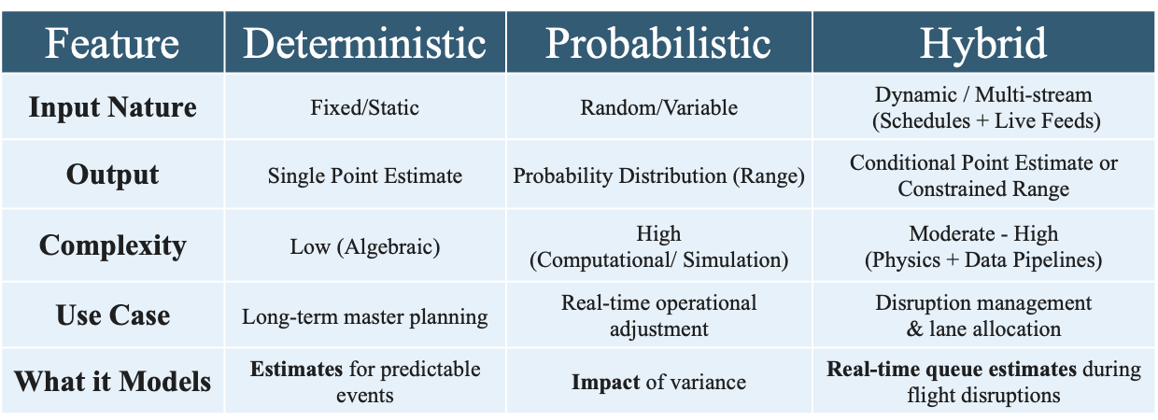
Figure 1. Forecasting Model Family Comparison
The predictive capabilities of each model configuration focus on performance measures: robustness, resilience, and generalizability. In this chapter, robustness refers to consistency under routine operating conditions, resilience refers to recovery after disruption, and generalizability refers to performance across different airports or terminal layouts.
Core Research Variables. Independent variables include scheduled flight departures, actual flight performance data, terminal structure categories, and origin-and-destination ratios. Dependent variables include TSA checkpoint throughput, queue wait times, and bottleneck formation rates. Model performance will also be evaluated as a secondary outcome.
Research Hypothesis. Distinct modeling frameworks and hybrid combinations thereof will exhibit asymmetric performance strengths across robustness, resilience, and generalizability. Probabilistic models are expected to outperform deterministic baselines under highly variable demand conditions, while hybrid models may perform better under disruption scenarios, as they combine system structure with operational data.
Hypothesis₁: Of the three different approaches to volatility forecast modeling (deterministic, probabilistic, and standard hybrid), no individual approach will prove superior across all three performance measures (resilience, robustness, and generalizability).
Design and Procedures. The execution of this research is structured into four sequential, iterative phases (Figure 2) designed to translate raw aviation data streams into comparative model performance results:
- Phase 1: Data Collection & Preprocessing (ETL)
  - Pull origin-and-destination estimates, load factor, TSA throughput & On-Time Flight Performance data from 2019-2025.
  - Filter 2019-2025 to preserve baseline operational validity.
  - Define metrics to evaluate each framework’s robustness, resilience, and generalizability.
- Phase 2: Model Development
  - Construct and calibrate static deterministic baselines queue structures to establish an operational control group.
  - Train probabilistic and data-driven time-series architectures (e.g., SARIMA and LSTM) to capture stochastic variance.
  - Program hybrid frameworks that dynamically integrate queuing theory with real-time flight schedule data.
- Phase 3: Evaluation Framework
  - Run model inferences against standardized baseline historical testing datasets.
  - Stress-test frameworks under simulated scenarios, such as peak asset constraints and operational failures.
  - Compute distinct metrics to evaluate each framework’s robustness, resilience, and generalizability.
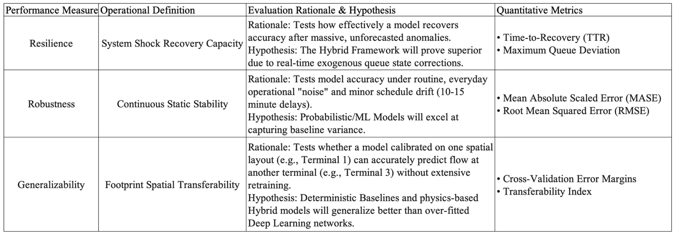
Figure 2. Evaluation Metric Definition
- Phase 4: Analysis and Interpretation
  - Map empirical performance outputs to initial foundational literature alignment.
  - Segment predictive insights into system-wide trends (both macro and micro) to deliver actionable recommendations.
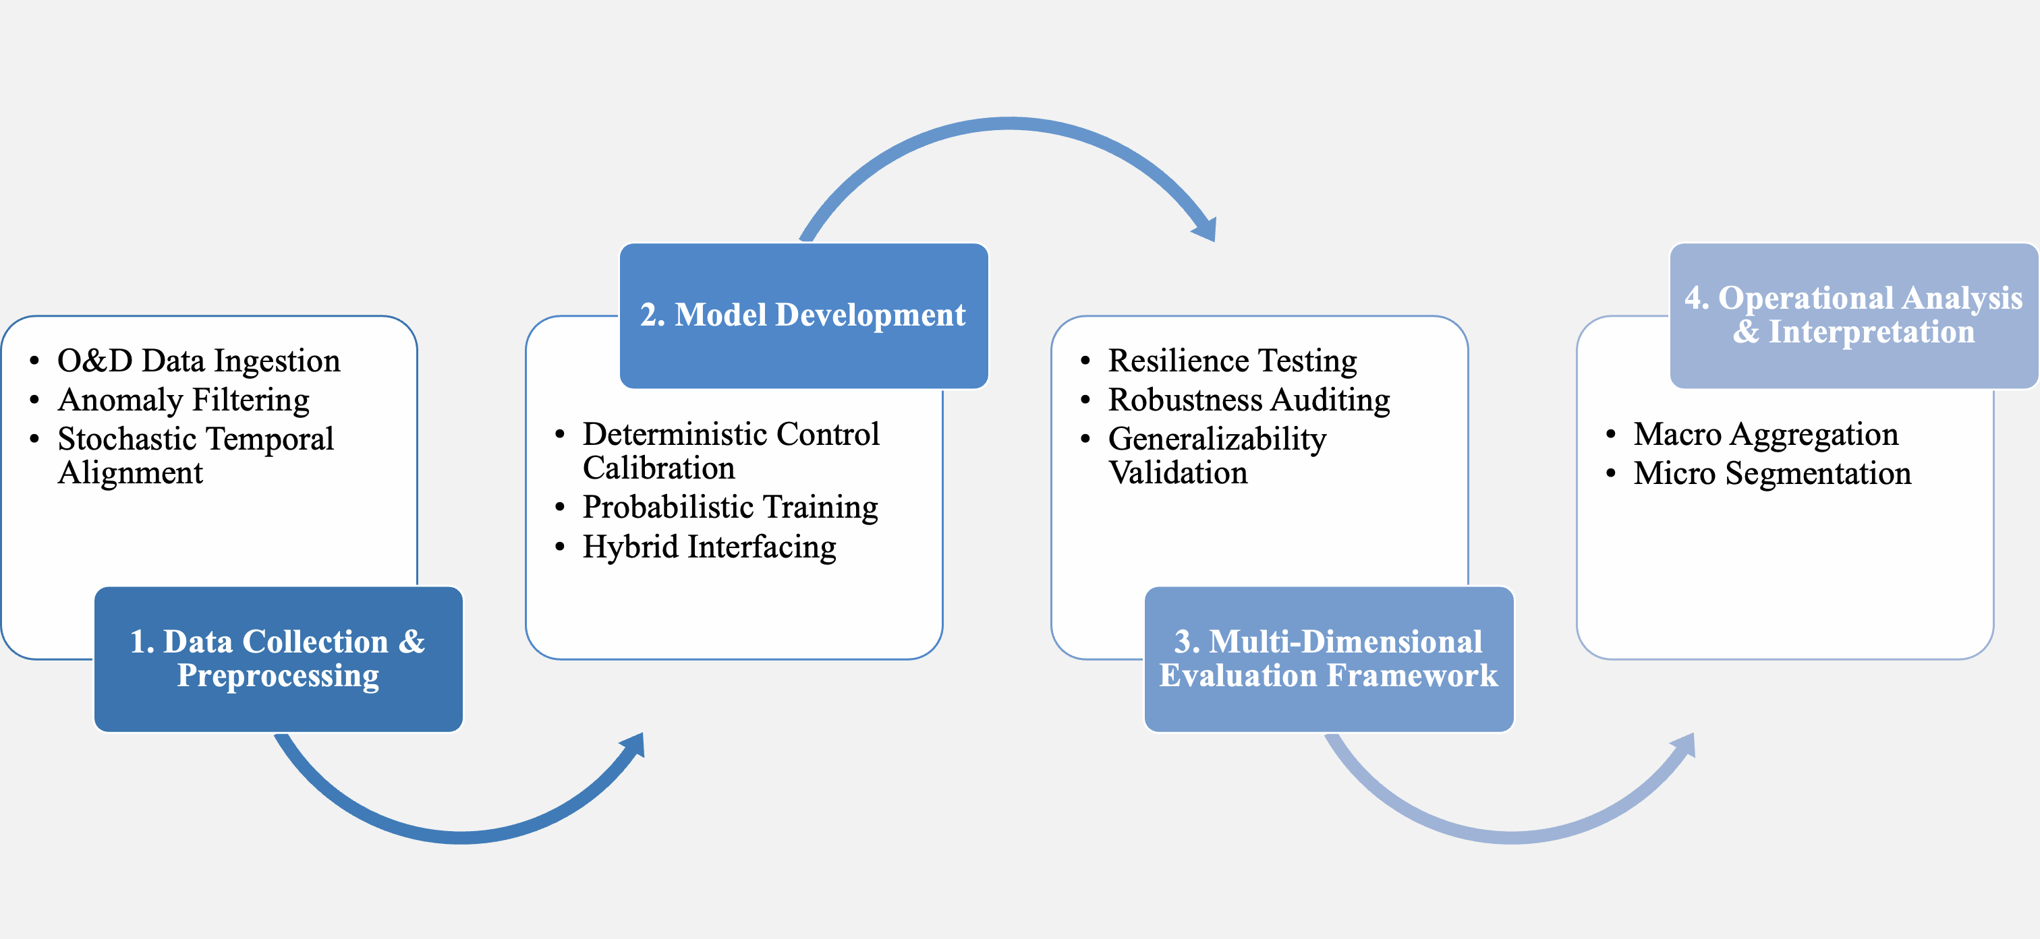
Figure 3. Design and Procedure Phases
Apparatus and Materials. To manage, parse, and evaluate the large data sets required for this study, the following software and computing resources are used:
- Google Antigravity and Python: Utilized as an integrated agentic framework and primary data ingestion engine to manage high-volume government data dumps during the ETL process. To ensure data integrity at this scale, custom scripts handled automated data pulling, unzipping, and parsing workflows in the data pipeline for downstream predictive modeling.
- Microsoft Excel for Mac & Microsoft Power BI: Deployed locally for advanced data transformation and visual validation.
- Vega High-Performance Computing (HPC) Cluster: The remote institutional environment used to execute the resource-intensive Python algorithms, filtering large-scale raw data down to determine airport and airline parameters.
Sample
The sample consists of airport checkpoint environments selected to reflect variation in terminal structure and airline dominance. Airports are grouped into structured categories (Figure 3, Figure 4) to account for how physical layout influences passenger distribution and checkpoint use (OAG, 2026). This strategy is intended to support comparison across terminal types and carriers rather than to claim complete uniformity across airports and airlines.
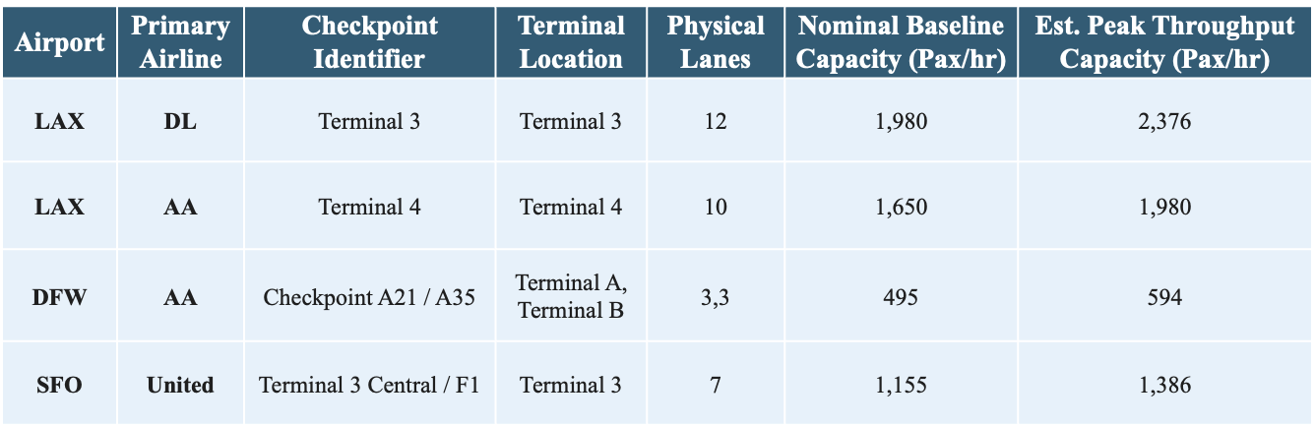
Figure 4. Sample Framework for Terminal Capacity and Checkpoint Configuration
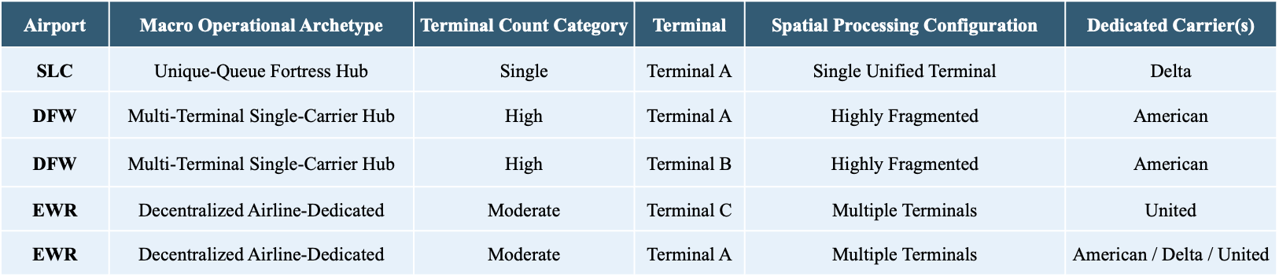
Figure 5. Airport Operational Archetypes and Terminal Configuration
Macro Categorization: Terminal-to-Airline Distribution. Airports are first classified into four structural archetypes to control for how airline market share impacts terminal distribution, with structural archetypes outlined below:
- Mega Hubs with No Dedicated Terminals (e.g., ATL, CLT, DEN): Sprawling operations where major legacy carriers share linear concourses or central ticketing, distributing passenger volume across shared screening areas.
- Decentralized Airline-Dedicated Terminals (e.g., LAX): Dispersed multi-terminal airports where distinct physical buildings are allocated exclusively to individual legacy carriers, isolating an airline's passenger wave to specific physical checkpoints.
- Single-Carrier Dedicated Mega-Terminals (e.g., DTW): Single-carrier "fortress" environments where a single dominant airline channels its entire domestic and international operation through one massive mega-terminal (e.g., Delta’s exclusive hold on the McNamara Terminal).
- Airports with Multiple Terminals Dedicated Exclusively to One Airline (e.g., DFW): Large-scale regional hubs requiring a single dominant carrier to distribute hub-and-spoke operations across multiple independent terminal buildings (e.g., American Airlines utilizing Terminals A, B, C, and E) to scale its operations.
Micro-Level Refinement: Checkpoint Co-Location and Isolation. While macro terminal assignments establish an operational baseline, localized checkpoint-level configurations ultimately determine queue characteristics. American Airlines, Delta Air Lines, and United Airlines are selected for analysis. The explicit criterion for inclusion is a domestic enplanement market share exceeding 10% at major United States hub airports (BTS, 2026). Recent reporting suggests Southwest’s boarding and carry-on system is both distinctive and inconsistent: the airline still relies on a differentiated low-fare brand, but its newer assigned-seating and baggage-fee policies have increased carry-on pressure and created boarding congestion (Boston 25 News, 2026). It is therefore not included in the study. To isolate the effects of low-cost carriers and unaligned traffic from legacy airline operations, the following terminal and checkpoint characteristics are defined to account for the impact of extenuating variables.
Shared Checkpoints with Limited Carrier-Level Separation (Centralized). In centralized hub models like Salt Lake City (SLC), a dominant carrier may hold the majority market share (70%), but a single consolidated terminal channels 100% of passengers through one primary security checkpoint. In these environments, it is not readily possible to isolate carrier-specific passenger flows using the available data structures.
Isolated Three Checkpoints (Decentralized). To find checkpoints highly unlikely to see Delta, American, or United traffic, the methodology prioritizes decentralized layouts with extreme carrier polarization, such as the following:
- DCA (Terminal 1): Consisting of Gates A1–A9, this terminal exclusively serves Air Canada, Frontier, and Southwest. American, Delta, and United are completely segregated into Terminal 2, creating a strong comparison setting for low-cost and regional carrier processing behaviors.
- SEA (Decentralized Main Terminal): Utilizing five separate security checkpoints across a footprint dominated by Alaska Airlines (52% market share). Checkpoints feeding Alaska-heavy gates or dedicated satellite concourses offer a high statistical probability of isolating non-Big Three passenger flows.
- CLT (Extreme Dominance Isolation): Where American Airlines controls 90% of the market share. Because Delta (2.5%) and United (2%) maintain a negligible footprint across the airport's 5 checkpoints, nearly any selected lane acts as a functional monoculture for a single legacy carrier's hub behavior.
Temporal Scope and Boundary Definition. To ensure structural modeling integrity, the temporal boundaries of this sample exclude the systemic operational volatility induced by the COVID-19 pandemic (Sun et al., 2021; Gao, 2022). While a baseline 'post-pandemic' operational era is provisionally considered as beginning January 1, 2023, an exploratory analysis is performed during data preprocessing to refine this demarcation due to varying definitions of ‘post-pandemic’ (ICAO, 2024; Centre for Aviation, 2025). This preprocessing step evaluates pre-pandemic baseline patterns against longitudinal 2019–2025 data to pinpoint the empirical inflection point where system throughput and schedule deviations returned to steady-state normalization. Restricting the active dataset to this verified window enables the forecasting models to more effectively capture contemporary queue dynamics and schedule-driven variability without being skewed by transient, historic anomalies.
Sources of the Data
Secondary operational data will be compiled from three primary repositories covering the 2019 to 2025 period. TSA checkpoint throughput data is obtained from TSA FOIA resources, on-time flight performance data, origin and departures, and load factors are drawn from the Bureau of Transportation Statistics, and origin-and-destination ratios are used to support passenger flow estimation from selected monthly airport reports, such as LAX Statistics (TSA, 2026; BTS, 2026; LAWA, 2026).
Validity
A threat to internal model validity is the presence of connecting passengers who remain airside and do not pass through a public checkpoint in load factor data. Including them in checkpoint demand estimates inflates predicted originating demand. To reduce this bias, origin-and-destination data is used to estimate and remove connecting traffic from passenger flow calculations. Construct validity is also affected by checkpoint heterogeneity, as the raw lane counts obtained from TSA Throughput data combine different screening modes, such as TSA PreCheck, and their corresponding processing rates.
Treatment of the Data
Extract:
- Download TSA Throughput files from FOIA reading room (PDFs) 2019-2026.
- Parse PDFs into tabular format (csv).
- Download TSA Throughput PDFs and CSVs 2022 – 2025 from GitHub Repository - https://github.com/mikelor/TsaThroughput.
- Cross-reference TSA datapoints to identify temporal gaps, duplicates and inconsistencies.
- Download On-Time Flight Performance data (CSVs) 2019-2026 for all domestic flights in the United States.
- Download T-100 Segment Airline Traffic Data and calculate monthly load factors.
- Perform an audit the 7-year sequence to identify missing data.
Transform
- Standardize timestamps to a uniform operational clock.
- Map and resolve typographical errors, airport names, data mismatches, and checkpoint errors.
- Normalize airport codes, checkpoint prefixes, and common terms (Checkpoint CKPT).
- Separate schedule flights from actual flights.
- Estimate seat capacities using flight distance, carrier and tail-name characteristics.
- Scale seat counts using load factor data to estimate passenger count.
- Merge datasets to determine terminal-specific connecting passengers within target dataset.
- Align Flight departure times with passenger lead-time assumptions and merged with hourly TSA throughput intervals to create a final modeling dataset.
Load
- Load master copies to OneDrive.
- Build analytics and lookup tables.
- Automate verification audits for validity and row preservation.

References
Adacher, L., & Flamini, M. (2020). Optimizing airport land side operations: Check-in, passengers’ migration, and security control processes. Journal of Advanced Transportation, 2020, 1–14. https://doi.org/10.1155/2020/6328016
Adadi, A., & Berrada, M. (2018). Peeking Inside the Black-Box: A Survey on Explainable Artificial Intelligence (XAI). IEEE Access, 6, 52138-52160.
Adeke, P. (2018). Modelling of queuing process at airport check-in system: A case study of Manchester and Leeds-Bradford airports. Nigerian Journal of Technology, 37(1), 35. https://doi.org/10.4314/njt.v37i1.5
Alfalasi, K. (2025). A Machine Learning Framework for Forecasting Passenger Flow at Dubai International Airport. ProQuest Dissertations & Theses.
AlKheder, S., Alhadeyah, S., & Albaghli, Z. (2024). Simulation modeling of passengers flow at airport terminals to reduce delay and enhance level of service. Case Studies on Transport Policy, 18, 101312. https://doi.org/10.1016/j.cstp.2024.101312
Alnowibet, K., Khireldin, A., Abdelawwad, M., & Wagdy Mohamed, A. (2022). Airport terminal building capacity evaluation using queuing system. Alexandria Engineering Journal, 61(12), 10109–10118. https://doi.org/10.1016/j.aej.2022.03.055
Alodhaibi, S., Burdett, R. L., & Yarlagadda, P. K. (2017). Framework for airport outbound passenger flow modelling. Procedia Engineering, 174, 1100–1109. https://doi.org/10.1016/j.proeng.2017.01.263
Anagnostopoulou, A., Tolikas, D., Spyrou, E., Akac, A., & Kappatos, V. (2024). The analysis and AI simulation of passenger flows in an airport terminal: A decision-making tool. Sustainability, 16(3), 1346. https://doi.org/10.3390/su16031346
Anupam, A. and Lawal, I. (2023). Forecasting air passenger travel: A case study of Norwegian aviation industry. Journal of Forecasting, 43(3), 661-672. https://doi.org/10.1002/for.3051
Araujo, G. E., & Repolho, H. M. (2015). Optimizing the airport check-in counter allocation problem. Journal of Transport Literature, 9(4), 15–19. https://doi.org/10.1590/2238-1031.jtl.v9n4a3
Ateş, S., Koç, G., Koç, T., & Bolat, M. (2021). Departure passenger flow simulation: Case study on Izmir Adnan Menderes Airport pre and post COVID-19. International Journal of Applied Mathematics Electronics and Computers, 9(3), 43–51. https://doi.org/10.18100/ijamec.928696
Bai, J., & Perron, P. (2003). Computation and analysis of multiple structural changes. Journal of Applied Econometrics, 18(1), 1-22.
Babu, C. N., & Reddy, B. E. (2014). A moving-average filter based hybrid ARIMA–ANN model for forecasting time series data. Applied Soft Computing, 23, 27–38. https://doi.org/10.1016/j.asoc.2014.05.028
Balliauw, M., & Onghena, E. (2020). Expanding airport capacity of cities under uncertainty: Strategies to mitigate congestion. Journal of Air Transport Management, 84, 101791. https://doi.org/10.1016/j.jairtraman.2020.101791
Bießlich, P., Schacht, M., & Wenzel, S. (2014). Application of discrete-event simulation for the analysis of passenger flows at airports. In Proceedings of the 2014 Winter Simulation Conference (pp. 1729–1740). IEEE. https://doi.org/10.1109/WSC.2014.7020023
Birolini, S., & Jacquillat, A. (2023). Day-ahead aircraft routing with data-driven primary delay predictions. European Journal of Operational Research, 310(1), 379–396. https://doi.org/10.1016/j.ejor.2023.02.035
Blasco-Puyuelo, J., Burrieza-Galán, J., Cantú Ros, O. G., Herranz, R., & Mocholí, D. (2023). A machine learning approach for predicting airport passenger flows. Proceedings of the SESAR Innovation Days. https://doi.org/10.61009/SID.2023.1.37
Boston 25 News. (2026, March 2). Southwest Airlines “refining” seating, boarding, baggage storage. https://www.boston25news.com/news/trending/southwest-airlines-refining-seating-boarding-baggage-storage/QKFNIHMN3BBSXC2CPF2NGIOZLY/
Brown, J. R., & Madhavan, P. (2011). Examining Passenger Flow Choke Points at Airports Using Discrete Event Simulation. NASA Technical Reports Server. https://ntrs.nasa.gov/citations/20110012091
Brun, A., Feron, E., Alam, S., & Delahaye, D. (2025). Schedule optimization and staff allocation for airport security checkpoints using guided simulated annealing and integer linear programming. Journal of Air Transport Management, 124, Article 102746. https://doi.org/10.1016/j.jairtraman.2025.102746
Brunetta, L., Righi, L., & Andreatta, G. (1999). An operations research model for the evaluation of an airport terminal: SLAM (simple landside aggregate model). Journal of Air Transport Management, 5(3), 161–175. https://doi.org/10.1016/S0969-6997(99)00010-1
Bruno, G., Diglio, A., Genovese, A., & Piccolo, C. (2018). A decision support system to improve performances of airport check-in services. Soft Computing, 23(9), 2877–2886. https://doi.org/10.1007/s00500-018-3301-z
Bureau of Transportation Statistics (BTS). (2026). Airline on-time performance data. U.S. Department of Transportation. https://www.bts.gov/
Campisi, T., Skuka, F., Ignaccolo, M., & Inturri, G. (2020). Metric evaluation of the transition towards a new normal of airport processes post COVID-19. Transportation Research Procedia, 48, 3604-3617.
Centre for Aviation. (2025). Airline industry completes full recovery with exceptional operational performance in 2024. https://centreforaviation.com/news/insights/airline-industry-completes-full-recovery-with-exceptional-operational-performance-in-2024-709251
Cheng, S., Zhang, Y., & Guo, Y. (2012). Theory of allocating and scheduling resources at airport passenger terminals: A review. Advanced Engineering Forum, 5, 66–70. https://doi.org/10.4028/www.scientific.net/aef.5.66
Chiti, F., Fantacci, R., & Rizzo, A. (2018). An integrated software platform for airport queues prediction with application to resources management. Journal of Air Transport Management, 67, 11-18. doi:10.1016/j.jairtraman.2017.11.003
De Neufville, R., & Odoni, A. R. (2014). Airport systems: planning, design, and management (Second edition.). McGraw-Hill.
Di Mascio, P., Moretti, L., & Piacitelli, M. (2020). Airport Landside Sustainable Capacity and Level of Service of Terminal Functional Subsystems. Sustainability, 12(21), 8784. https://doi.org/10.3390/su12218784
Diaz-Gutierrez, J., Nazir, N., Longo, N., & Ranjbari, A. (2025). Mitigating airport congestion through variable message signs and model predictive control algorithms. Transportmetrica (Abingdon, Oxfordshire, UK), 1–29. https://doi.org/10.1080/23249935.2025.2559146
Ebert, A., Dutta, R., Mengersen, K., Mira, A., Ruggeri, F., & Wu, P. (2021). Likelihood-free parameter estimation for dynamic queueing networks: Case study of passenger flow in an international airport terminal. Journal of the Royal Statistical Society: Series C (Applied Statistics), 70(3), 770–792. https://doi.org/10.1111/rssc.12487
Edwards, J. (2026, April 8). Digital twin technology for airports: Real-time simulation and predictive operations. Oxmaint. https://oxmaint.com/industries/aviation-management/digital-twin-technology-airports-real-time-simulation
FAA. (2024). FAA aerospace forecast: Fiscal years 2024–2044. U.S. Department of Transportation. https://www.faa.gov/data_research/aviation/aerospace_forecasts/faa-aerospace-forecast-fy-2024-2044.pdf
Farida, Y., Akbar, F., Hafiyusholeh, M., & Hartono, M. (2021). Analysis of landing airplane queue systems at Juanda International Airport Surabaya. Cauchy: Jurnal Matematika Murni Dan Aplikasi, 7(1), 49–63. https://doi.org/10.18860/ca.v7i1.12772
Fernandes, E., & Pacheco, R. R. (2002). Efficient use of airport capacity. Transportation Research. Part A, Policy and Practice, 36(3), 225–238. https://doi.org/10.1016/S0965-8564(00)00046-X
Gao, Y. (2022). Benchmarking the recovery of air travel demands for US airports during the COVID-19 Pandemic. Transportation Research Interdisciplinary Perspectives, 13, Article 100570. https://doi.org/10.1016/j.trip.2022.100570
Giannopoulou, E., Demestichas, P., Katrakazas, P., Saliverou, S., & Papagiannopoulos, N. (2026). AI-Powered Service Robots for Smart Airport Operations: Real-World Implementation and Performance Analysis in Passenger Flow Management. Sensors (Basel, Switzerland), 26(3), 806. https://doi.org/10.3390/s26030806
Gopichand, G., Sarath, T., Devi, V., Srivastava, V., Lonial, I., Acharya, R., & Thakur, A. (2025). Flight delay prediction based on delay time using predictive analytics. International Journal of Aeronautical and Space Sciences, 26(4), 1940–1953. https://doi.org/10.1007/s42405-024-00855-w
Gu, X., Xie, J., Huang, C., & Liu, J. (2022). A spatiotemporal passenger distribution model for airport terminal energy simulation. Indoor and Built Environment, 31(7), 1834–1857. https://doi.org/10.1177/1420326x221074222
Guizzi, G., Murino, T., & Romano, E. (2009). A discrete event simulation to model the airport passenger flow. Proceedings of the 8th WSEAS International Conference on System Science and Simulation in Engineering, 427–434.
Güner, S., & Seçkin Codal, K. (2024). Airport productivity and network centrality in the pandemic outbreak: Lessons from the Turkish airports. Journal of Air Transport Management, 115, Article 102552. https://doi.org/10.1016/j.jairtraman.2024.102552
Guo, J., Tong, X., Yang, Y., Yuan, J., & Xu, S. (2025). Resilience analysis of airport systems based on improved Bayesian networks. International Journal of Computational Intelligence Systems, 18(1), Article 176. https://doi.org/10.1007/s44196-025-00914-4
Guo, J., Tong, X., Yang, Y., Yuan, J., & Xu, S. (2025). Resilience analysis of airport systems based on improved Bayesian networks. International Journal of Computational Intelligence Systems, 18(1), Article 176. https://doi.org/10.1007/s44196-025-00914-4
Guo, X., Grushka-Cockayne, Y., & De Reyck, B. (2022). Forecasting Airport Transfer Passenger Flow Using Real-Time Data and Machine Learning. Manufacturing & Service Operations Management, 24(6), 3193–3214. https://doi.org/10.1287/msom.2021.0975
Had, P., Volt, J., & Stojić, S. (2025). Calculation of queue formation and queue length at airport check-in counters. Acta Polytechnica CTU Proceedings, 52, 17–23. https://doi.org/10.14311/app.2025.52.0017
He, J., Li, Y., & Chao, Y. (2024). Research on prediction and optimization of airport express passenger flow based on fusion intelligence network model. Applied Sciences, 14(24), Article 11886. https://doi.org/10.3390/app142411886
Hess, S., & Grbčić, A. (2019). The multiphase queuing system of the Rijeka Airport. Scientific Journal of Maritime Research, 33(2), 205–209. https://doi.org/10.31217/p.33.2.10
Hewamalage, H., Bergmeir, C., & Bandara, K. (2021). Recurrent Neural Networks for Time Series Forecasting: Current status and future directions. International Journal of Forecasting, 37(1), 388–427. https://doi.org/10.1016/j.ijforecast.2020.06.008
Hopfe, D. H., Lee, K., & Yu, C. (2024). Short-term forecasting airport passenger flow during periods of volatility: Comparative investigation of time series vs. neural network models. Journal of Air Transport Management, 115, Article 102525. https://doi.org/10.1016/j.jairtraman.2023.102525
International Air Transportation Association (IATA). (2026, March 17). Air travel demand will more than double by 2050 [Press release]. https://www.iata.org/en/pressroom/2026-releases/2026-03-17-01/]
International Civil Aviation Organization (ICAO). (2024). Effects of novel coronavirus (COVID‐19) on civil aviation: Economic impact analysis. Air Transport Bureau. https://www.icao.int/economic-impacts-covid-19-civil-aviation
Jenčová E., Gajdušková T., Jezný M., & Hudák P. (2025). Identification of bottlenecks in passenger handling processes using data-driven tools. Applied Sciences, 15(15), 8760. https://doi.org/10.3390/app15158760
Jia, Y., & Wang, C. (2025). An integrated aircraft scheduling model based on flight delay propagation and improved column generation algorithm. Aircraft Engineering and Aerospace Technology, 97(3), 301–308. https://doi.org/10.1108/AEAT-04-2024-0113
Jiang, B., Zhang, J., Fu, J., Ding, G., & Zhang, Y. (2024). Research on Check-In Baggage Flow Prediction for Airport Departure Passengers Based on Improved PSO-BP Neural Network Combination Model. Aerospace, 11(11), 953. https://doi.org/10.3390/aerospace11110953
Jie, Z., Shuainan, D., Bengang, G., Zhenchao, M., & Jiamin, J. (2024). Research on temporal and spatial distribution characteristics of passenger flow of Daxing airport line based on automatic fare collection data. Expert Systems, 41(6). https://doi.org/10.1111/exsy.13009
Karsu, Ö., & Solyalı, O. (2023). A new formulation and an effective matheuristic for the airport gate assignment problem. Computers & Operations Research, 151, Article 106073. https://doi.org/10.1016/j.cor.2022.106073
Kazda, A., Badanik, B., & Serrano, F. (2022). Pandemic vs. Post-Pandemic Airport Operations: Hard Impact, Slow Recovery. Aerospace, 9(12), 810. https://doi.org/10.3390/aerospace9120810
Kim, C., & Kim, H. (2013). Spatial-temporal analysis of recent air passenger flows. International Journal of Applied Geospatial Research, 4(4), 37–57. https://doi.org/10.4018/jagr.2013100103
Kumano, S., Mizoguchi, M., Takine, T., & Fukushima, M. (2005). Optimal operation of airport landside flow with multiple inspections. Transactions of the Institute of Systems, Control and Information Engineers, 18(4), 146–155. https://doi.org/10.5687/iscie.18.146
Lee, Y., Choi, S. C., Lee, K., & Cho, S. W. (2025). Dynamic rescheduling strategy for passenger congestion balancing in airport passenger terminals. Mathematics, 13(13), 2208. https://doi.org/10.3390/math13132208
Lemer, A. (1988). Measuring airport landside capacity. Transition Research Record 1199. Retrieved from http://onlinepubs.trb.org/Onlinepubs/trr/1988/1199/1199-002.pdf
Leone, K., and R.R. Liu. (2011). "Improving Airport Security Screening Checkpoint Operations in the US via Paced System Design", Journal of Air Transport Management, 17: 62-67
Li, X., de Groot, M., & Bäck, T. (2023). Using forecasting to evaluate the impact of COVID‐19 on passenger air transport demand. Decision Sciences, 54(4), 394–409. https://doi.org/10.1111/deci.12549
Li, Y., & Gao, G. (2023). Large-scale passenger behavior learning and prediction in airport terminals based on multi-agent reinforcement learning. Frontiers in Computing and Intelligent Systems, 5(1), 111–117. https://doi.org/10.54097/fcis.v5i1.111
Li, Z., Bi, J., & Li, Z. (2017). Passenger Flow Forecasting Research for Airport Terminal Based on SARIMA Time Series Model. IOP Conference Series. Earth and Environmental Science, 100(1), 12146. https://doi.org/10.1088/1755-1315/100/1/012146
Liao, M., Cheung, T. K. Y., Wong, C. W. H., & Zhang, A. (2025). Resilience in the face of disruptions: Assessing the impacts of COVID-19 and geopolitical conflicts on global airport connectivity. Journal of the Air Transport Research Society, 4, Article 100069. https://doi.org/10.1016/j.jatrs.2025.100069
Lin, L., Liu, X., Liu, X., Zhang, T., & Cao, Y. (2023). A prediction model to forecast passenger flow based on flight arrangement in airport terminals. Energy and Built Environment, 4(6), 680–688. https://doi.org/10.1016/j.enbenv.2022.06.006
Lin, W. (2022). Atmospheric conditioning: Airport automation, labour and the COVID‐19 pandemic. Transactions - Institute of British Geographers (1965), 47(1), 214–228. https://doi.org/10.1111/tran.12499
Liu, Y. (2018). Research on airport security based on virtual queuing theory. Advances in Intelligent Systems Research, 147, 7–11. https://doi.org/10.2991/ncce-18.2018.2
Lu, C., Hongqing, Z., & Wang, S. (2018). Bottleneck detection of security checking process for airport throughput optimization. Destech Transactions on Engineering and Technology Research. https://doi.org/10.12783/dtetr/icmeit2018/23465
Los Angeles World Airports (LAWA). (2026). Statistics for LAX. Investor Relations. Retrieved May 24, 2026, from https://www.lawa.org/lawa-investor-relations/statistics-for-lax
Lu, C.-H., Zhou, H.-Q., & Wang, S.-H. (2018). Bottleneck detection of security checking process for airport throughput optimization. DEStech Transactions on Engineering and Technology Research. https://doi.org/10.12783/dtetr/icmeit2018/23465
Mansor, M., Ibrahim, N., Jamil, S., Shafie, N., & Zahari, S. (2023). Visualising the optimistic, realistic, and pessimistic financial distress outlooks for airport operations in Malaysia. Journal of Cases on Information Technology, 25(1), 1–20. https://doi.org/10.4018/JCIT.324103
Marks, A., Rietsema, K., & Al-Ali, M. (2015). Airport information systems—Landside management information systems. Intelligent Information Management, 7(3), 130–138. https://doi.org/10.4236/iim.2015.73012
Marzuoli, A., Boidot, E., Feron, E., & Srivastava, A. (2019). Implementing and validating air Passenger–Centric metrics using mobile phone data. Journal of Aerospace Information Systems, 16(4), 132-147. doi:10.2514/1.I010625
Monmousseau, P., Jarry, Bertosio, F., Delahaye, D., & Houalla, M. (2020). Predicting passenger flow at Charles De Gaulle Airport security checkpoints (pp. 1–9). IEEE. https://doi.org/10.1109/aida-at48540.2020.9049190
Mota, M. M., Scala, P., Bernardi, A. D., & Orozco, A. (2021). Restart: Analysis of post-COVID 19 capacity in security checkpoints at Mexico City Airport. Transportation Research Procedia (Online), 59, 234–243. https://doi.org/10.1016/j.trpro.2021.11.115
Naji, M., Braytee, A., Al-Ani, A., Anaissi, A., Goyal, M., & Kennedy, P. J. (2020). Design of airport security screening using queueing theory augmented with particle swarm optimisation. Service Oriented Computing and Applications, 14(2), 119–133. https://doi.org/10.1007/s11761-020-00291-0
Nazhif, M., Huda, H., & Yuzal, I. (2018). Managing passenger movement flow with green concept area: Terminal 2, Soekarno-Hatta International Airport. [Paper presentation]. https://doi.org/10.2991/grost-17.2018.72
Nazir, N., Vasisht, S., Choudhury, S., Zoepf, S., & Dowling, C. (2022). Mitigating landside congestion at airports through predictive control of diversionary messages. arXiv. https://doi.org/10.48550/arxiv.2209.13837
Nikoue, H., Marzuoli, A., Clarke, J.-P., Feron, E., & Peters, J. (2015). Passenger Flow Predictions at Sydney International Airport: A Data-Driven Queuing Approach. https://doi.org/10.48550/arxiv.1508.04839
Nwofia, O., & Chung, C. A. (2013). A methodology for designing airports for enhanced security using simulation. Journal of Aviation Technology and Engineering, 3(1), 2–8. https://doi.org/10.7771/2159-6670.1066
Olusanya, O., Obetta, J., Oyediram, M., & Elegbede, A. (2020). Development of a model for international traveler’s check-in process using Arena software tool. Engineering, 12(11), 811–823. https://doi.org/10.4236/eng.2020.1211057
Oprea, C., Rosca, M., Rosca, E., Costea, I., Ilie, A., Dinu, O., & Ruscă, A. (2024). Analyzing Passenger Flows in an Airport Terminal: A Discrete Simulation Model. Computation, 12(11), 223. https://doi.org/10.3390/computation12110223
Orhan, İ., & Orhan, G. (2020). Modelling and managing airport passenger flow: A case of Hasan Polatkan Airport in Turkey. International Journal of Aviation Science and Technology, 1(2), 71–79. https://doi.org/10.23890/ijast.vm01is02.0204
Orsini, F., Gastaldi, M., Mantecchini, L., & Rossi, R. (2019). Neural networks trained with WiFi traces to predict airport passenger behavior (pp. 1–7). IEEE. https://doi.org/10.1109/mtits.2019.8883365
Ozores, C. (2026, April 29). Airports must monetize their assets to fund infrastructure needs. PA Consulting. https://www.paconsulting.com/newsroom/airport-magazine-airports-must-monetize-their-assets-to-fund-infrastructure-needs-29-april-2026
Parlar, M., Rodrigues, B., & Moosa, S. (2016). Event‐based allocation of airline check‐in counters: A simple dynamic optimization method supported by empirical data. International Transactions in Operational Research, 25(5), 1553–1582. https://doi.org/10.1111/itor.12332
Patrón, R., Scala, P., Mota, M., & Mendoza, A. (2021). Airport passenger flow prediction using simulation data farming and machine learning. [Conference proceedings]. https://doi.org/10.46354/i3m.2021.emss.023
Pitchforth, J., Wu, P., Fookes, C., & Mengersen, K. (2015). Processing passengers efficiently: An analysis of airport processing times for international passengers. Journal of Air Transport Management, 49, 35–45. https://doi.org/10.1016/j.jairtraman.2015.06.016
Perez, E., Taunton, L., & Sefair, J. A. (2021). A Simulation-Optimization Approach to Improve the Allocation of Security Screening Resources in Airport Terminal Checkpoints. Proceedings - Winter Simulation Conference, 2021, 1–11. https://doi.org/10.1109/WSC52266.2021.9715421
Peterson, M. D., Bertsimas, D. J., & Odoni, A. R. (1995). Models and algorithms for transient queueing congestion at airports. Management Science, 41(8), 1279–1295. https://doi.org/10.1287/mnsc.41.8.1279
Rady, H. (2017). Empirical analysis of passenger self-service implementation in Cairo International Airport. International Journal of Heritage, Tourism and Hospitality, 11(1), 17–29. https://doi.org/10.21608/ijhth.2017.27863
Ribeiro, N. A., Tay, J., Ng, W., & Birolini, S. (2025). Delay predictive analytics for airport capacity management. Transportation Research Part C: Emerging Technologies, 171, Article 104947. https://doi.org/10.1016/j.trc.2024.104947
Rodriguez-Sanz, A., Marcos, A. F. D., Perez-Castan, J. A., et al. (2021). Queue behavioural patterns for passengers at airport terminals: A machine learning approach. Journal of Air Transport Management, 90, 101940. https://doi.org/10.1016/j.jairtraman.2020.101940
Saki, S., & Soori, M. (2026). Artificial intelligence, machine learning and deep learning in advanced transportation systems, a review. Multimodal Transportation, 5(1), Article 100242. https://doi.org/10.1016/j.multra.2025.100242
Schultz, M., Luo, M., Lubig, D., Mota, M. M., & Scala, P. (2021). Covid-19-Related Challenges for New Normality in Airport Terminal Operations. Proceedings - Winter Simulation Conference, 1–12. https://doi.org/10.1109/WSC52266.2021.9715417
Schultz, T., & Fricke, H. (2011). Passenger flow modeling and simulation at airport terminals. Transportation Research Part C: Emerging Technologies, 19(2), 296–308. https://doi.org/10.1016/j.trc.2010.05.016
She, Y., Zhao, Q., Guo, R., & Yu, X. (2022). A robust strategy to address the airport gate assignment problem considering operators’ preferences. Computers & Industrial Engineering, 168, Article 108100. https://doi.org/10.1016/j.cie.2022.108100
Solak, S., Clarke, J. P. B., Johnson, E. L., & Barnes, E. R. (2009). Optimization of airport terminal capacity expansion under uncertainty. Transportation Research Part B: Methodological, 43(8–9), 808–824. https://doi.org/10.1016/j.trb.2009.02.008
Sun, X., Wandelt, S., & Zhang, A. (2022). COVID-19 pandemic and air transportation: Summary of Recent Research, Policy Consideration and Future Research Directions. Transportation Research Interdisciplinary Perspectives, 16, 100718. https://doi.org/10.1016/j.trip.2022.100718
Sun, X., Wandelt, S., Zheng, C., & Zhang, A. (2021). COVID-19 pandemic and air transportation: Successfully navigating the paper hurricane. Journal of Air Transport Management, 94, 102062. https://doi.org/10.1016/j.jairtraman.2021.102062
Takakuwa, & Oyama. (2004). Simulation analysis of international-departure passenger flows in an airport terminal. 2003 Conference Winter Simulation, 2, 1627–1634 vol.2. https://doi.org/10.1109/WSC.2003.1261612
Tang, H., Yu, J., Lin, B., Geng, Y., Wang, Z., Chen, X., Yang, L., Lin, T., & Xiao, F. (2023). Airport terminal passenger forecast under the impact of COVID-19 outbreaks: A case study from China. Journal of Building Engineering, 65, 105740. https://doi.org/10.1016/j.jobe.2022.105740
Transportation Security Administration (TSA). (2026). FOIA electronic reading room. U.S. Department of Homeland Security. https://www.tsa.gov/foia/electronic-reading-room
Verki, H., Mamdoohi, A., & Saffarzadeh, M. (2013). Stochastic planning approach in airport passenger terminals. Journal of Traffic and Logistics Engineering, 1(1), 77–81. https://doi.org/10.12720/jtle.1.1.77-81
Viaña, J., Cohen, K., Saunders, S., Marx, N., & Cobb, B. (2024). Explainable algorithm to predict passenger flow at Cincinnati/Northern Kentucky International Airport. Transportation Research Record, 2678(2), 839–862. https://doi.org/10.1177/03611981231176814
Wang, C. (2018). A queueing analysis of a security-check system with two types of inspection channels. [Paper presentation]. https://doi.org/10.2991/mmsa-18.2018.23
Wang, M. (2017). Application of the queuing theory in characterizing and optimizing the passenger flow at the airport security. Journal of Applied Mathematics and Physics, 5(9), 1620-1628. https://doi.org/10.4236/jamp.2017.59134
Wang, X., Shi, Z., & He, M. (2022). Airport traffic prediction based on similar day PSO-SVM. Computer Simulation, 39(7), 86–90.
Wang, Y., Jiang, W., Zhang, M., & Li, D. (2025). Airspace monitoring around airports using neural network-based systems and analysis of predictive capabilities and real-time data integration. International Journal of Information Technologies and Systems Approach, 18(1), Article 386845. https://doi.org/10.4018/IJITSA.386845
Wei, Y. (2017). Optimization model of airport security screening. [Conference proceedings]. https://doi.org/10.2991/emim-17.2017.214
Wu, P. P.-Y., Pitchforth, J., & Mengersen, K. (2014). A Hybrid Queue-based Bayesian Network framework for passenger facilitation modelling. Transportation Research. Part C, Emerging Technologies, 46, 247–260. https://doi.org/10.1016/j.trc.2014.05.005
Wu, S. (2024). Research on airport passenger flow forecast based on PSO-BP neural network. In M. Mikusova (Ed.), Proceedings of SPIE, the International Society for Optical Engineering (No. 130181U; Vol. 13018). SPIE. https://doi.org/10.1117/12.3023949
Wu, Y., Yang, J., Chen, X., Lin, Y., & Yang, H. (2024). Long-term airport network performance forecasting with linear diffusion graph networks. IEEE Transactions on Intelligent Transportation Systems, 25(11), 18264–18278. https://doi.org/10.1109/TITS.2024.3420423
Xia, Z., Li, B., Huang, H., Huang, L., Wang, X., & Li, J. (2020). An ensemble learning model for short-term passenger flow prediction. Complexity, 2020, 1–13. https://doi.org/10.1155/2020/6694186
Xiangzhi, Z., Shanmei, L., & Li, S. (2025). Risk-Aware Multi-Horizon Forecasting of Airport Departure Flow Using a Patch-Based Time-Series Transformer. Aerospace, 12(12), 1107. https://doi.org/10.3390/aerospace12121107
Xie, G., Wang, S., & Lai, K. K. (2014). Short-term forecasting of air passenger by using hybrid seasonal decomposition and least squares support vector regression approaches. Journal of Air Transport Management, 37, 20–26. https://doi.org/10.1016/j.jairtraman.2014.01.009
Yang, S., Tang, T., & Wang, T. (2022). How to raise the check-in efficiency at an airport terminal: A route guidance strategy. IEEE Access, 10, 97692–97700. https://doi.org/10.1109/access.2022.3206458
Zhang, C., Jin, Z., Ng, K. K. H., Tang, T.-Q., Zhang, F., & Liu, W. (2025). Predictive and prescriptive analytics for robust airport gate assignment planning in airside operations under uncertainty. Transportation Research Part E: Logistics and Transportation Review, 195, Article 103963. https://doi.org/10.1016/j.tre.2025.103963
Zhang, X., Li, J., & Xiang, N. (2017). Airport security process optimization based on GSPN and queuing theory. ITNEC: 2017 IEEE 2nd Information Technology, Networking, Electronic and Automation Control Conference: 15-17 December 2017, 1810–1814. https://doi.org/10.1109/ITNEC.2017.8285107
Zhang, C., Jin, Z., Ng, K. K. H., Tang, T.-Q., Zhang, F., & Liu, W. (2025). Predictive and prescriptive analytics for robust airport gate assignment planning in airside operations under uncertainty. Transportation Research Part E: Logistics and Transportation Review, 195, Article 103963. https://doi.org/10.1016/j.tre.2025.103963

